EXCLUSIVE NOTES PREPARATION FOR SUBJECTS
Exclusive notes on many subjects of Mechanical Engineering has been prepared by the faculty members of this department and distributed to the students to enable them to learn the subjects better. These notes contain important questions, critical analysis of problems with clearly depicted solutions. These notes serve as a helping tool for them and serve to enhance their performance in exams.
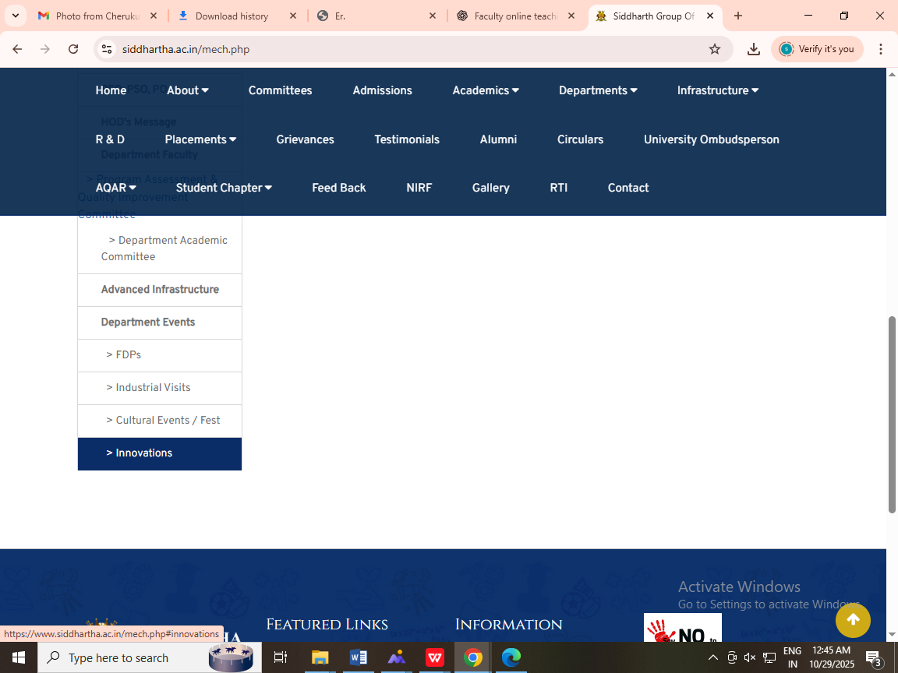

EXCLUSIVE VIDEOS COLLECTION AND DISPLAY FOR SUBJECTS
Exclusive videos have been collected by the faculty in different subjects for displaying them to students during discussions in class rooms. These videos enhance their understanding abilities and create more interest towards learning the subjects.
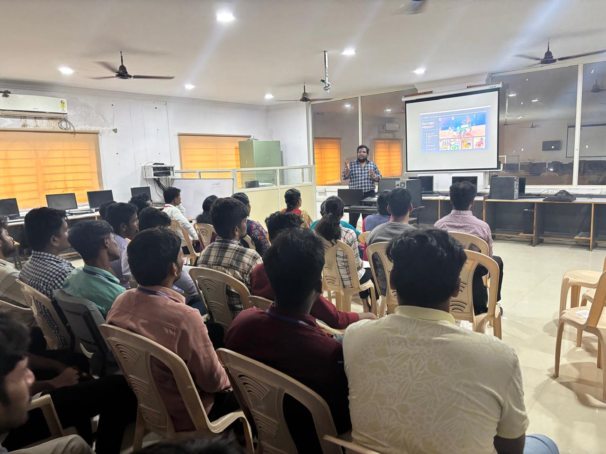
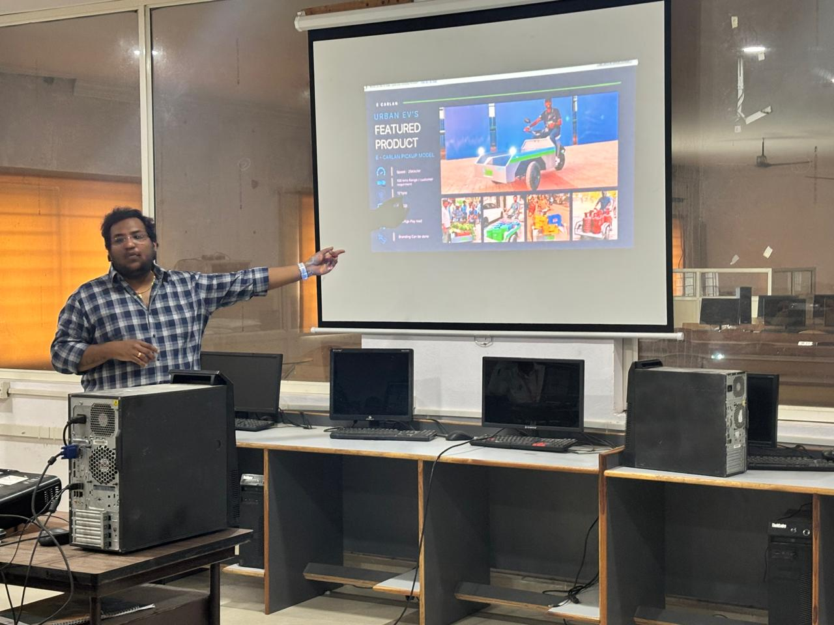
Faculty Demonstration of Electric Vehicle (EV) Working.

EXCLUSIVE NPTEL FACILITY FOR STUDENTS FOR LISTENING TO SPECIAL LECTURES
An exclusive audio-visual facility has been developed and is being maintained to listen to NPTEL lectures by experts from IITs. This facility is being used by the faculty and students and enables them to listen to lectures in addition to the regular class room teaching. Faculty and students upgrade their knowledge by listening to these lectures. This facility is available in the library and departmental laboratory.
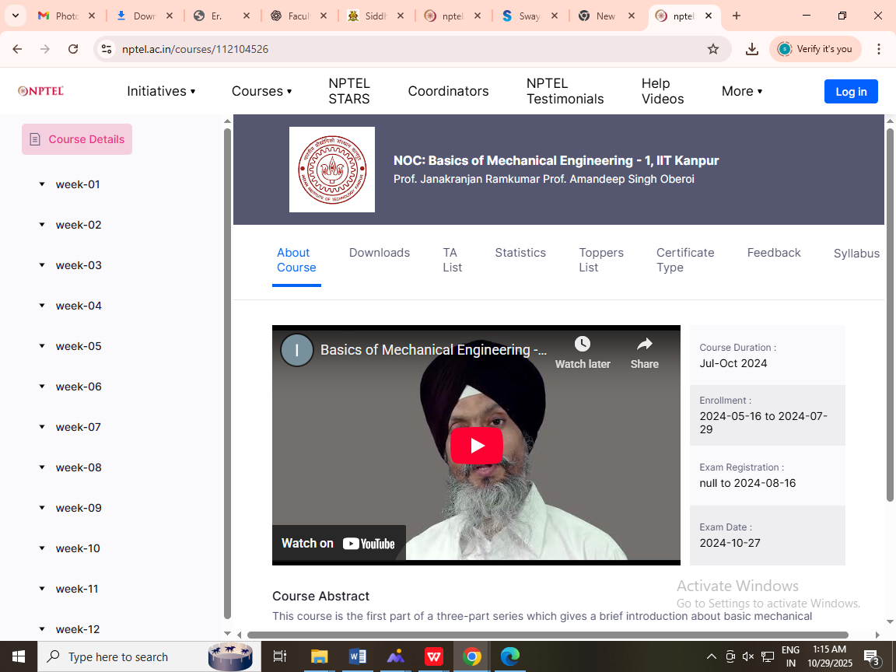
Students Engaged in Learning Basic Mechanical Engineering via NPTEL Videos

